Script:

Good Habits

1. File: good habits 1
2. Download worksheet (worksheet number 1)
3. Interactive Exercise 1 Match the name of the emotion to the facial expression.

Joy, acceptance, happiness, sadness, anger, stress, satisfaction, helplessness, fear, anxiety, nervousness, excitement, calmness, enthusiasm, disappointment, shame, boredom, curiosity, relief, tension, trust, wrath, impatience, amusement, surprise, pride, focus, fatigue/

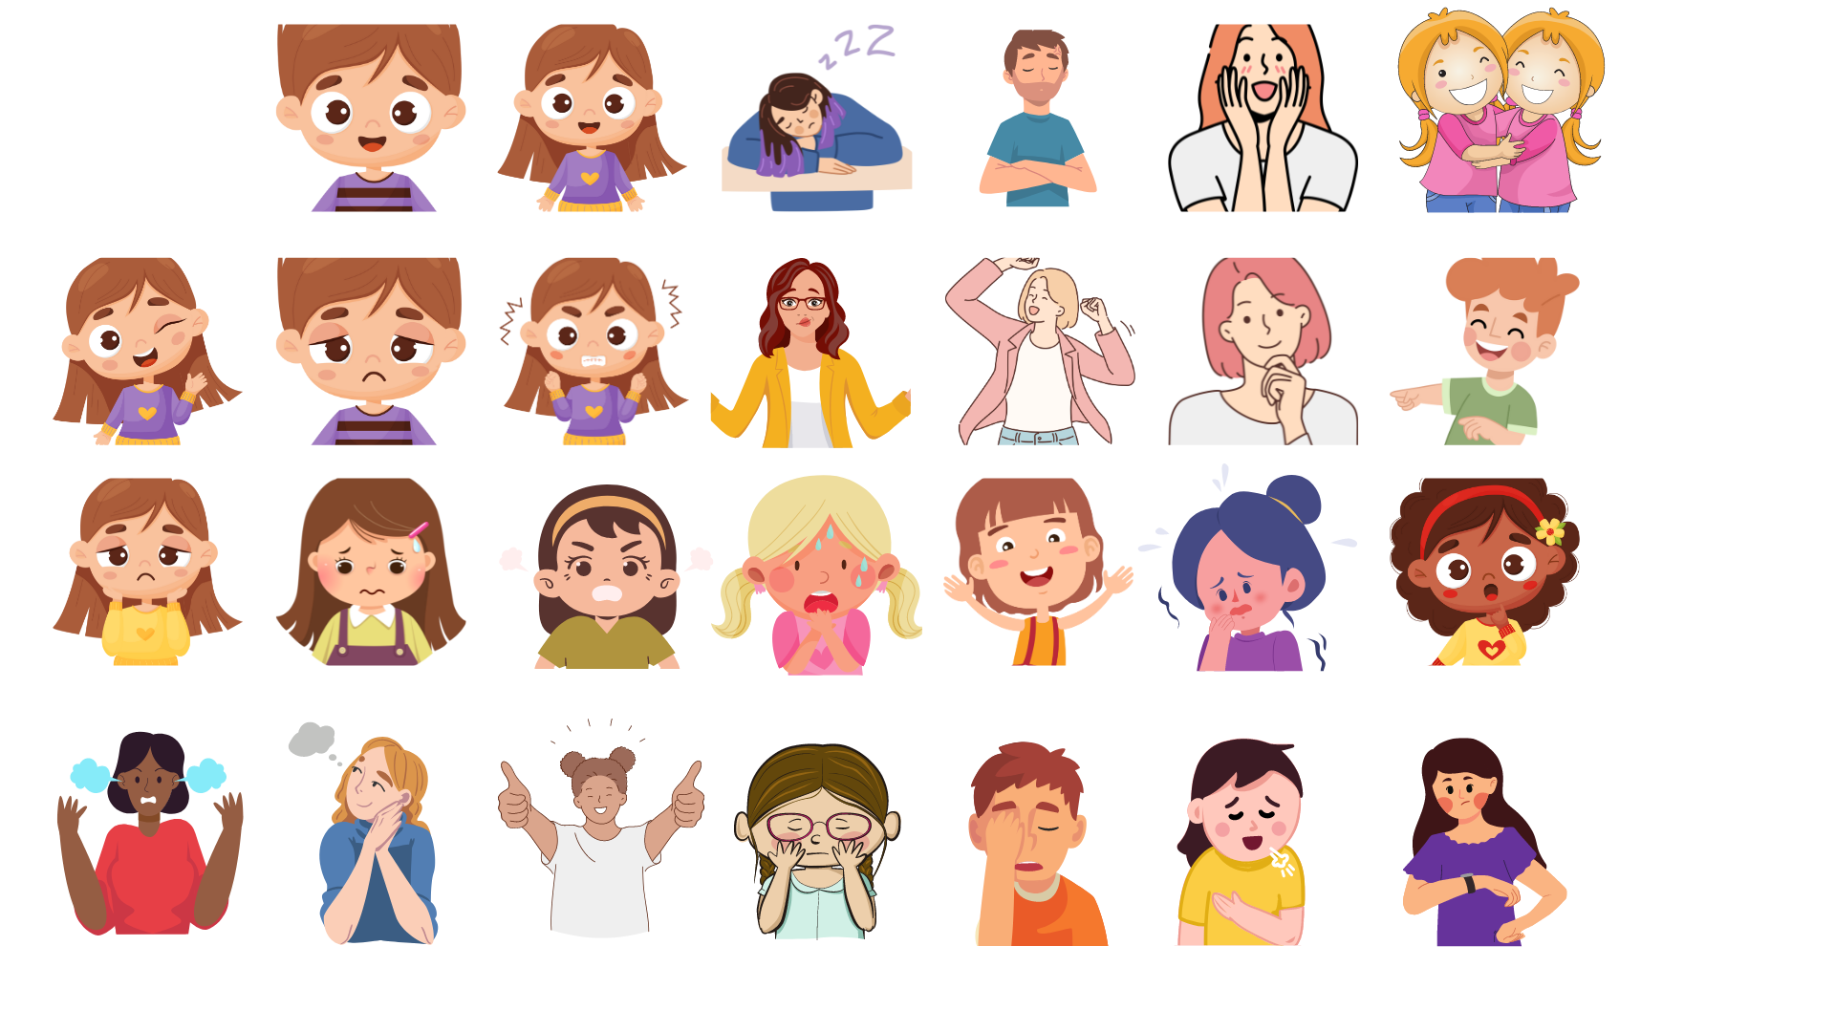

Solution:

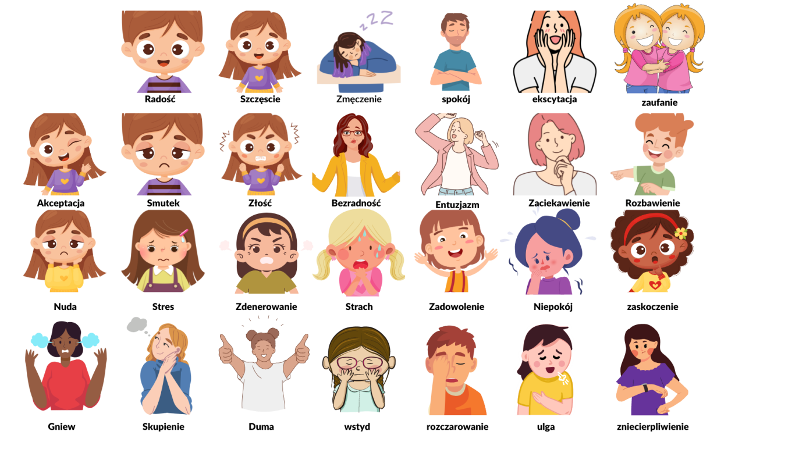

1. File: good habits 2

Interactive Exercise 2

Attention! Emotion! Stop. Check your internal weather forecast.

Step 1 Notice the emotion and name it Check what emotion is present here and now, at this moment. Do you know already? Name it. Great. I feel …………………… (insert emotion name here)

Step 2 Now, consider how strongly you feel this emotion Instruction:

Imagine a thermometer, or draw one and have it handy; then mark (in your mind or on the drawing) the strength of your emotion. The thermometer is universal, it works throughout the day, in every place. You can try it when you feel different emotions. When they are pleasant emotions, it's worth expressing them through dance, singing, playing, drawing, playing a musical instrument, or other favorite activities. Then we are even more relaxed and creative.

Determine the intensity of your emotion on a scale from 0 to 20 for emotions that want to come out and from 0 to -20 for emotions that want to hide deeper. This is level ………………….. (insert the correct number)

Instructions (-20 degrees down, 20 degrees up, point 0 is neutral). Mark the degrees up in red, the degrees down in blue, point 0 remains white. The blue scale indicates the strength of what you feel and what you want to hide deeper and deeper, the further down, the more invisible to the surroundings; The red scale indicates the strength of what you feel, the further up, the closer you are to a state where you won't be able to hold back the emotion and there will be a strong outpouring, like a volcano eruption. What level is it? Is it approaching red 10? Maybe it's around red 3? Or maybe it's an emotion that makes you want to hide and be alone? How difficult is it for you with this emotion? Is it at blue 5 or closer to 20? Or maybe it's an emotion that you can't name, but experiencing it is also difficult for you?

Interactive Exercise 3 Worksheet - Nature (interactive)

View a gallery of images depicting nature in various forms. Nature, like a human, experiences different "weather conditions". Try to give titles to individual illustrations, reaching for names of emotions.

Try to answer the following questions:

1. Was it an easy task?
2. Which photo was the most difficult to title and why?
3. Is recognizing and naming your own emotions easy? Why? What is easiest and what is most difficult about naming emotions?
4. What could help you to name/recognize your emotions (e.g. observing others' reactions, isolation, time for yourself, silence, etc.)?
5. How would you name the emotion that is currently accompanying you?
6. What is the Celsius temperature of your emotion?
7. File: good habits 3