Scenario
Turn It into Fun
Lesson Objective:
• You will learn what a ritual is and understand its role.

Video about rituals before entering the classroom
What is a ritual?
• What do you think about a teacher who starts lessons like this?
• Would you like to go to such a school and greet the teacher like that?
• Why are rituals important?
• Can you give an example of other rituals?
Ritual
When we learn a new habit, at first, we are very aware of it, but over time, as we gain skill, the habit becomes automated. We enter a kind of trance, and our body (and mind) already know what to do.
Maybe rituals are funny, but they also have a very important role – they help us focus on the goal, concentrate.
Stages of habit automation
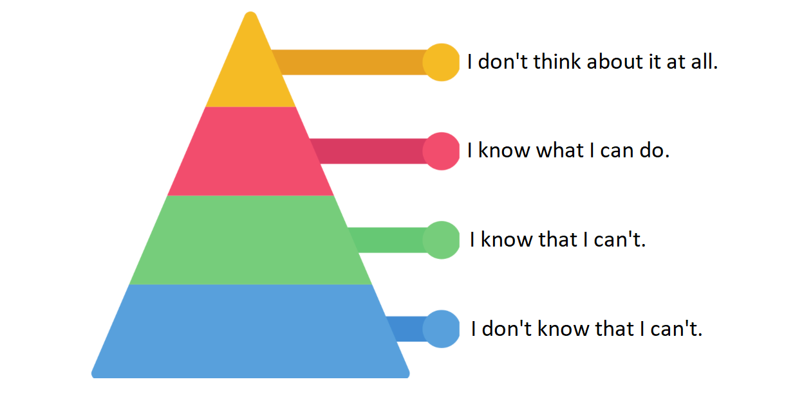
Stage 1
I don't know that I can't – for example, I have no idea how to start/drive a car and I don't even think about it.
Stage 2
My friend says that as soon as he turns 16, he'll start learning to drive – he wants to learn as soon as possible. I listen to him and realize that... I already know that I don't know how to do it.
Stage 3
I learn to drive and already know what I can do, but I also know that I have to focus and be attentive.
Stage 4
I know so well that I don't even think about it – all the actions are synchronized, I don't have to remind myself constantly what I should do.
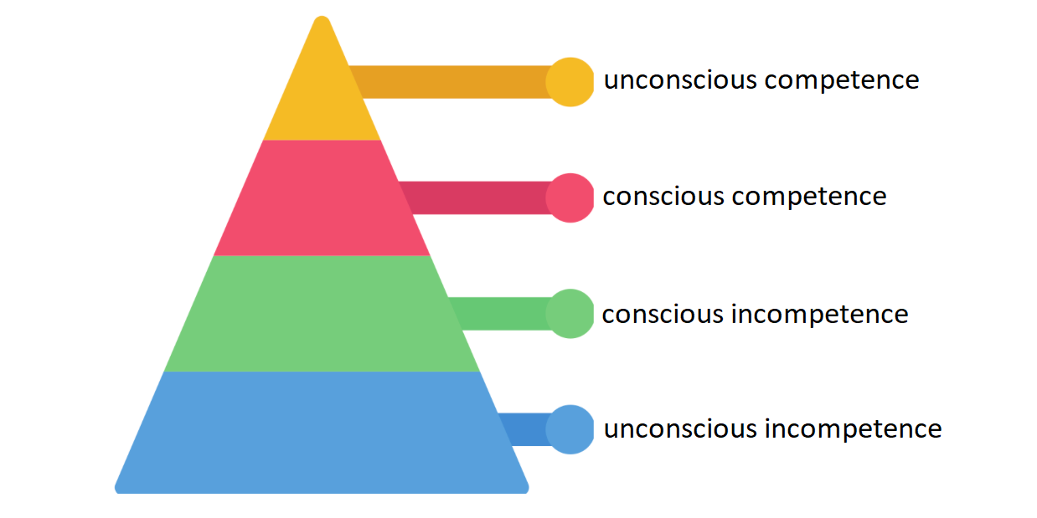
Give a signal – start a ritual
Do you remember our first lesson about habits?
The first one is the signal. Our brain behaves like a dog – it likes to learn, but it's often distracted, so to make it obedient, you have to give it tasks and reward it for good performance. This is called conditioning. You can teach your brain that every time you start a lesson, you make yourself your favorite tea in your favorite mug. After a while, when you take out your favorite mug from the cupboard, your brain will know: "Ah, now we're getting to work!" and won't protest.
Famous people and their rituals:
J.K. Rowling, author of the Harry Potter series, has a daily ritual of taking a long walk. She believes that walking outdoors helps her in the creative process and inspires her writing.
The Dalai Lama, spiritual leader of Tibet, practices meditation and prayer daily. It is a ritual for him that allows him to develop inner peace, ensures mental and spiritual health, and develops empathy and love for others.
Footballer Cristiano Ronaldo is famous for his intense training routines and taking care of his body. His ritual includes daily gym workouts, exercises on the neuromobilization track, cryotherapy, as well as specialized meals and sleep at specific times of the day.

