LESSON PLAN

Standards of Beauty versus Real Life

To start today's lesson, I have a question for you - do you know what the beauty standard is?

Students respond…

Teacher:

The beauty standard is a pattern/norm regarding external appearance traits that are considered desirable/good/beautiful (?) These are so-called ideals that have changed multiple times over the years. In the 17th century, a woman with full figures, which today might be called plump, was considered the beauty standard. Roundness was associated with a positive image of a woman. Thinness, on the other hand, was then considered a sign of belonging to lower social classes and poverty.

For several decades now, the standard of a slim or very slim figure has still dominated, recognized as the beauty standard. Often the image of the female ideal is entirely unrealistic to achieve. Let's look at an example on the infographic.

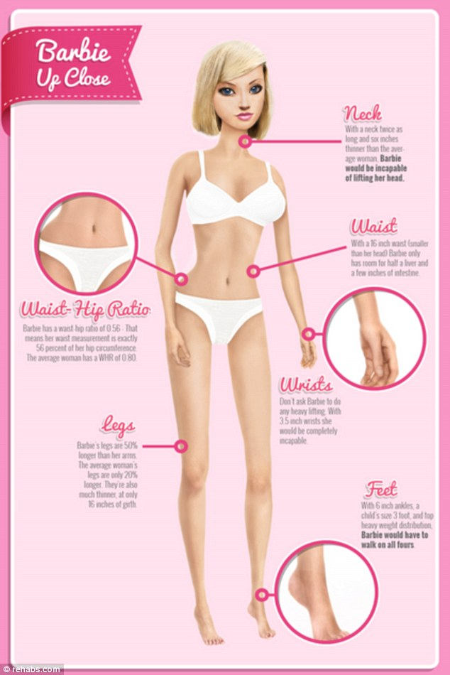

Barbie, a doll known to almost every person in the world. Perhaps we do not realize how the silhouette of little girls' favorite dolls worldwide influences their perception of beauty as they grow up. Australian researchers made the appropriate calculations to illustrate the dimensions of the human body corresponding to those presented by Barbie and Ken dolls.

Now prepare a measuring tape or any other you have at home.

Look at the infographic and what dimensions, for example, the neck and biceps should have if we wanted to recreate the dimensions presented by the popular doll. Now, using the measuring tape, check how it looks in practice.

For example, measure what the head of an adult would look like with a circumference of 23 cm or a biceps with a circumference of 17 cm. We are talking about an adult, and as you can see, the dimensions rather correspond to those of children. It's hard not to agree with the statement that Barbie's presented canon of a beautiful silhouette does not entirely align with the dimensions of the human body in the real world.

The teacher asks questions:

• What other actions do you know, e.g., in the media, that promote an unrealistic image of beauty? Maybe you know a TV program or a social media profile that you associate with such actions?

• Are you able to recognize when photos have been subjected to graphic editing to hide certain features and emphasize others?

• What do you think about beauty? What is your definition of the beauty standard?

It's time to examine the realities that surround us.

Question: Have you ever, for example, while waiting for a bus at a bus stop, observed the people around you? If so, didn't you notice that there is a huge diversity in terms of our appearance (but also personality) in the world? If you have never made such an observation, try it at the next opportunity! It's interesting what conclusions you'll come to then.

In the world of sports and business, you can meet many successful women who are not of petite stature, meaning their silhouette does not fit the current beauty standard. However, their stories show that external appearance does not say much about who we are as people and what our strengths are.

For example, the tennis star - the leader of world rankings for many years - Serena Williams - is recognized as one of the best tennis players in the history of the sport, a woman with a muscular posture, far from the standards considered ideal or beautiful. During her career, Williams earned over $85 million, making her the highest-earning female tennis player in the history of the sport. Her career and titles are excellent evidence that in life, there are many values unrelated to appearance that are worth developing to be happy. What is also worth emphasizing in Williams' case is the fact that she achieved tremendous success, although life was very difficult for her to bear. Her sister - Yetunde - was killed in a shooting. This event greatly affected her, and for a long time, she struggled to recover. Despite such hardships, Serena did not give up and put all her life energy into training tennis, becoming the best female tennis player in the world.

Discussion

Teacher: Now I ask you to summarize today's lesson - what do you think about the beauty standard? Did Serena's example impress you? Do you have any personal conclusions about external appearance? How do you approach the image of beauty in the media? Do you have your own standards? I encourage you to discuss these questions and answers with a colleague or friend. Have fruitful discussions.

Summary and Homework

Teacher: Most images of the female body in the media, for example, in advertisements, on magazine covers, in television programs, usually present one type of silhouette - referred to as slim or very slim. However, this is a silhouette that is by no means the most popular among women worldwide. It is worth remembering that behind what is currently considered the beauty standard are always other people - specialists from companies who earn huge sums to evoke in us a sense of being imperfect.

The source of their profits are precisely all products, treatments, and services that are supposed to improve our appearance. But do we really need to improve anything? As seen in the example of a world-class tennis player, focusing on what we feel, how we want to live, and what to do to achieve success and live in happiness gives fantastic results. Perhaps it is worth considering what should really be important in life?

What we really look like doesn't say much about us. What we appreciate about ourselves, but also what others highly value about us, you will find out from the homework. It consists of two parts. You fill out the first one, and someone close to you - so ask your mom, dad, or another close person to participate in the task.