**Scenario:**

**Where Do Habits Come From**

* Today's lesson is "0."
* You will learn 4 laws and 3 practices.

**Think About It**

Someone once said, "You are what you eat," but in reality, you are what you consume, and this isn't just about food. It also includes what (and whom) you listen to, what you read, what you watch, and the people you interact with daily. All of this is nourishment for your body, mind, and emotions.

* And you? What do you feed your body, mind, and heart?
* Watch the video and pay attention to the differences in your lifestyle.
* What are your habits related to eating? Physical activity? Work? Social interactions?

**Small Quiz to Start - Do You Know What You Eat?**

1. **Why is water important for our health?**
   * a) It helps in digesting food
   * b) It maintains proper blood pressure
   * c) It enhances flavor
2. **What vitamins are essential for our body?**
   * a) Vitamin A, B, C, D, E, K
   * b) Vitamin X, Y, Z
   * c) Vitamin F, G, H
3. **What are flavor enhancers and why should we avoid them?**
   * a) They are substances added to food to improve taste and smell, but they can have negative health effects.
   * b) They are vitamins added to food to enrich it.
   * c) They are natural food ingredients that improve taste and smell.
4. **Why is it important to eat healthy breakfasts?**
   * a) They give us energy for the whole day
   * b) They help us focus on learning and other tasks
   * c) It's just a myth, and breakfasts are unnecessary.
5. **What fats are beneficial for our health?**
   * a) Unsaturated fats, such as canola oil and olive oil
   * b) Trans fats, such as margarine
   * c) Saturated fats, such as lard and butter
6. **What is a balanced diet?**
   * a) It is a diet that contains the right amount of nutrients needed for health and well-being.
   * b) It is a diet based on only one type of food.
   * c) It is a diet aimed at quick weight loss.

**For Individual Work**

* Reflect on your eating habits – what can't you resist? Chips? Gummies? Cola? Chocolate?
* Have you ever wondered why salty or sweet snacks are so attractive to us?
* Find an advertisement for sweets or soft drinks. Look at the colors, see how the people in the ad behave – how do advertisers try to influence us – the consumers – to buy their product?
* Did you know that the marketing departments of big companies work tirelessly to make you buy their product? Have you ever thought about what such work looks like? No? Well, you have a chance now.

Specialists in advertising know how to appeal to our senses. Let's look at a bag of chips. What senses does this signal stimulate?

* **Sight** – attractive, colorful packaging
* **Hearing** – catchy name, rustling package, crunchy chips – our brain likes contrasts, it thinks: "Aha, soft inside, crunchy outside – interesting"
* **Smell** – artificial, intense smell combining fat and salt
* **Touch and shape** – chips are ridged, twisted into spirals, perfectly oval like Pringles
* **And of course, TASTE** – the combination of salt and fat that our brain likes

Many people work to create a strong SIGNAL, because the strength of the signal determines our RESPONSE.

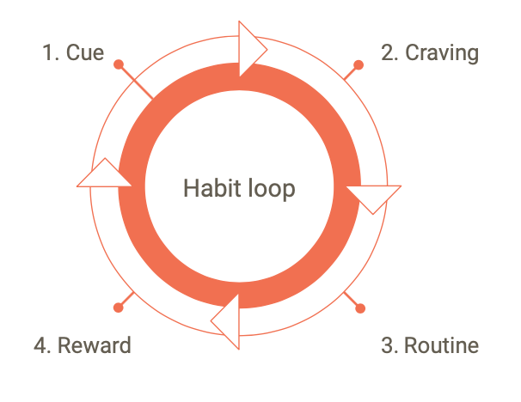

**WORKSHEET**

* Choose your favorite activity that you want to do regularly. It could be exercising, reading books, drawing, etc.
* Draw a picture on a piece of paper representing your favorite activity.
* Look closely at your picture and think about what could be your signal, something that encourages you to start this activity. It could be, for example, seeing your task notebook, your favorite song, etc. Draw your signals around the picture.
* Next, think about what desire you want to satisfy by performing this activity. It could be, for example, the desire to learn something new, to relax, etc. Draw your desires around the picture.
* Now think about what steps you can take to start this activity. You can, for example, set a specific time of day when you will do it, set a reminder on your phone, etc. Draw your steps under the picture.
* Finally, think about the reward you will receive after performing your activity. It could be, for example, a feeling of pride in yourself, the opportunity to do something else, etc. Draw your rewards around the picture.

With this worksheet, you will better understand how to create positive habits and what motivates you. Good luck in creating your habits!

**For Individual Work**

Marketing specialists in the food industry know exactly what they're doing. They use knowledge of how our brain functions, but unfortunately, they don't always use this knowledge for our benefit. :(

Every habit, good or bad, follows a certain pattern. Regardless of whether the habit is good or bad – the pattern is the same.

**Let's look at the habit loop:**

* **SIGNAL** – the signal is something that appeals to us, attracts our senses. I walk into a store and see a bag of chips, the colors are vivid, my favorite movie character is on the package.
* **CRAVING** – when we see something attractive, it triggers the desire to use it, our brain automatically expects a reward. The attractive, colorful package of golden, crunchy chips promises this reward.
* **RESPONSE** – if I don't have strong willpower, and remember, a whole team of people works to create the perfect chip – I'm done, I walk into the store, buy a bag of chips and...
* **REWARD** – I enjoy the crunchy, salty, ridged chips, and my REWARD CENTER jumps with joy.

**So, what is a habit?**

A habit is an action that we repeat so often and regularly that it becomes automatic and we stop noticing it.

Our life consists of habits – both good and bad.

**And what are yours? What are you proud of? What would you like to get rid of? Give at least one example.**

**Homework**

* Go shopping at the supermarket with your mom, dad, or grandma, take a small worksheet with you and mark where the following items are located: bread/eggs/yogurt/sweets in small packages – chewing gum, candy bars, candies.
  + In most stores, the bread shelves are at the very end of the store. Why do you think that is?
  + In most stores, candy bars/candies/cigarettes/chewing gum are right at the checkout. Why?

**For Individual Work**

Our life depends on habits. What we regularly eat, whether we exercise, read, develop, learn regularly or give up, gorge on sweets, and spend the day lying on the bed and watching videos on TikTok.

You may not see it now, but think for a moment – if for the next few years you live on chips, sit at home with your phone in hand – how will you feel? What will you look like?

Aristotle, the Greek philosopher, said: "We are what we repeatedly do." First, we shape our habits, but then they shape us and what we do daily, regularly, affects our well-being, intellectual development, appearance.