Scenario
Take a Look at Yourself
We start with a task!
Look at the list below. Put a + next to each habit you consider good/beneficial, 0 next to each you consider neutral, and – next to each you consider negative:
- I bite my nails
- I read a lot
- I eat sweets every day
- I do my homework right after coming home from school
- I wake up at 7
- I turn off the alarm
In this lesson:
- You will think about your habits, both good and not so good
- Where they come from and what is the first step to change
- You will list and categorize your habits
- You will consider which ones are worth working on
- You will learn what influences effective habit change
Julia’s Story Julia is a 7th-grade student. She likes to study, is interested in biology, and wants to go to a good high school next year. She dreams of becoming a marine biologist and saving endangered species. Unfortunately, Julia has been having problems at school lately. She often arrives late, is inattentive in class, and finds it hard to concentrate. She recently got two failing grades in her favorite subject. If this continues, Julia will lose her chance to go to her dream school.
- Look at what an average day in Julia's life looks like, paying particular attention to her habits.
- What would you suggest to her as a friend?
- What should Julia change in her daily routine to concentrate better?
- What should she start/stop/limit doing?
- What do you think Julia would gain if she started following your advice?
Julia’s Day
- 6:00 AM - I wake up with difficulty after 6 hours of sleep, lie in bed until 6:30, scrolling through my phone
- 6:30 AM - I get up, brush my teeth, spend some time finding something to wear, pack my school bag (but often forget something)
- 7:00 AM - I eat breakfast on the go, glancing at my phone; sometimes it's too late for breakfast, and I have to rush to school without preparing anything at home. I buy snacks at the school shop.
- 7:15 AM - I run to school
- 8:00 AM - I start classes, but I am half-asleep and doze off a bit during the first lesson, my stomach growling with hunger
- 8:45 AM - I run to the school shop and buy a small can of cola and a candy bar
- 12:00 PM - Long break. I don't like school lunches, my friend has instant noodles, I pour hot water over them and eat them for lunch
- 3:00 PM - I finish school and rush to math tutoring, buying a sweet bun at the bakery on the way so I don't die of hunger
- 5:00 PM - I finish tutoring and go home
- 6:00 PM - I eat something quickly, take the dog out for 10 minutes, my head hurts a bit
- 7:00 PM - I sit down to do homework, try to study, but notifications keep coming and their sound distracts me, my headache gets worse
- 9:00 PM - I bring cookies and strong tea from the kitchen, it's hard for me to focus
- 11:00 PM - I wash up, go to bed, and lie in the dark listening to music on headphones and browsing TikTok, chatting with friends
- 12:00 AM - I fall asleep with headphones on
Task 2: My Good and Bad Habits Take up to 10 minutes for this task. Sit comfortably and think about your typical day. How do you spend it? Everything you do in life is some form of habit: whether you choose cereal or a sandwich for breakfast (or maybe you don't eat breakfast at all?), whether you read in the evening or scroll through your phone. Even thinking about yourself in a certain way is a habit. This is actually good news, because if you don't think highly of yourself – you can change that. Don't believe it?
"I am who I am - and there's nothing I can do about it!" You’ve probably heard this many times. Many people use it as an argument. "I am shy," "I am nervous," or, worse: "I am stupid." Renowned American psychologist, Professor Carol Dweck, in her book "Mindset," claims that almost everything in our lives depends on our mindset. If we have a GROWTH mindset – we move forward and treat failures along the way as valuable lessons. If we have a FIXED mindset – failures are just more proof that "it can't be done."
So – if you want to change something in your life – you must change your mindset. What is yours?

Experiment
In a certain school, there were two English teachers: Mrs. Grabowska and Mrs. Kwiatkowska. Both were experienced teachers, both had been teaching for 10 years and had decent results. One day, the principal called them in and said:
This school year, we decided to divide the classes based on talent: Mrs. Grabowska will get the class of olympians – very talented children who like to work hard and all want to get into the best high schools. They are ambitious kids, maybe not the easiest to handle, but they have great potential. And Mrs. Kwiatkowska will have to work with the terrible 6a class this year, where children don’t want to learn and cause disciplinary problems. Next year, they will switch classes to be fair.
What do you think happened after a year?
Exactly. Class 6b achieved great results, with several olympians and two laureates of the competition, while class 6a was even worse than the year before. The catch was that the principal had played a joke on the two teachers – both classes had students who were eager to learn as well as those who didn't want to learn at all. The difference was in how the teachers viewed them.
So what does this mean?
Share your thoughts.

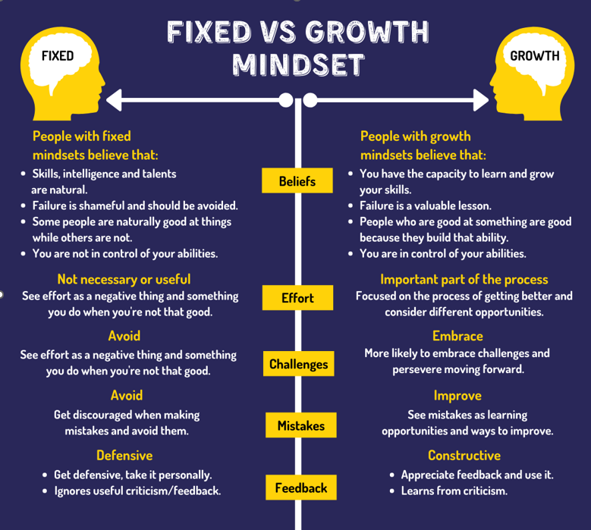
What do you think can be learned from this experiment?
How we see the world around us and ourselves determines the results we achieve.

A small test at the end! And you? What are you like?
- Challenges paralyze me, I prefer to avoid them
- I like challenges, they drive me
- The successes of others make me happy and inspire me
- I give up easily
- I don't like to exert myself. What's the point?
- I like to get a bit tired sometimes. Resting after exertion feels better

