Scenario
Pleasure with benefit
Objective of the Session:
• Learn how to train your brain to combine pleasure with purpose.

Habits can be cool.
Our brain loves rewards.
It's worth combining WANT and HAVE TO:
pairing habits together, for example: when I finish my math homework (HAVE TO), I'll watch an episode of my favorite TV show (WANT).

Train Your Brain
What do you need to do to teach a dog to sit? Just repeat the command "sit" several times and give him a treat as a reward for completing the task.
Our brain behaves very similarly, it loves rewards, and if we want to teach it a new trick, we have to reward it. :)

WANT and HAVE TO List
In our lives, there are many things that we simply enjoy doing, and no one has to force us to do them. Of course, everyone has their own individual list of things that bring them pleasure, but few teenagers need to be forced to play computer games, ride a bike, or play with their beloved dog.
You have two backpacks:
• Put things you WANT to do in one, i.e., pleasures.
A bike trip? Playing Monopoly? Skateboarding? Reading a book?
• Put things you HAVE TO do in the other:
Doing homework? Walking the dog? Studying math? Cleaning the room?

Drawing of two backpacks
I. Things I WANT TO do
II. Things I HAVE TO do

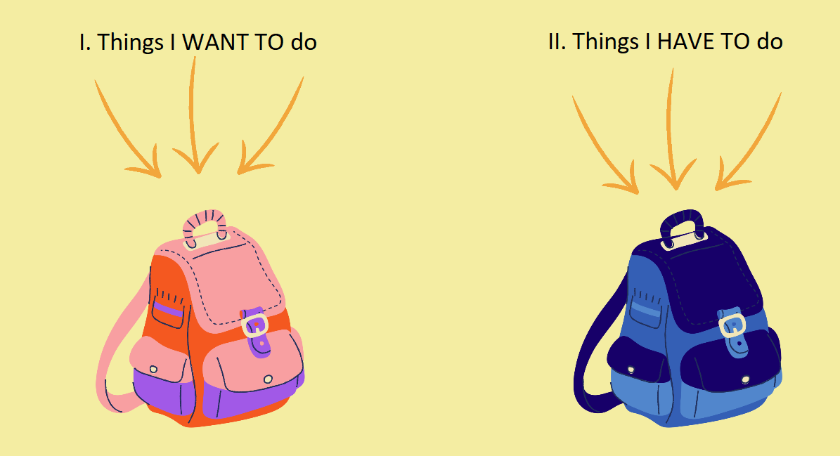

Win-Win, or Both Parties Benefit
• What does win-win mean?
• Is it always about winning or losing?
• Can we try to negotiate differently?
Imagine you share a computer with your younger sister. You want to play your favorite online game on Saturday afternoon, and she wants to watch her favorite princess TV show. What solution can you propose so that instead of arguing, both of you can use the computer?
A story about a basket of oranges is perfect for this, about which two sisters argued one day. Each of them wanted it for herself. And both thought that their needs couldn't be reconciled. What are the possible solutions to this situation?
Their mother takes the basket away because they can't agree. Neither of them gets the oranges, neither is happy.
Only one of them gets the oranges – so only one is happy. The other might feel unfairly treated.
They split the oranges in half. Each is somewhat happy, but not entirely...
And there's one more possibility – the sisters talk to each other and it turns out that their interests are not contradictory at all. One wants to squeeze the oranges for juice, and the other wants to dry their peel for baking. When they discover this, they can share the oranges, and both are happy.

CASE STUDY
And What If...?
Combine Pleasure with benefit
Michalina's daily obligation is to walk the dog when she returns from school. Michalina loves her dog, enjoys playing with him, but walks are simply... boring to her. As a result, she walks around the block and returns home dragging Lucy on the leash. Neither Michalina nor Lucy benefits from this; the dog needs not only to relieve herself but also to meet other dogs, sniff and analyze the scent trails of other animals. Did you know that this sniffing is hard intellectual work for a dog, like studying for a biology test is for you? Michalina loves reading books, she can spend a long time in an armchair with a book, she adores long romantic stories. But you can't read while walking the dog, can you?
Do you think Michalina could do something to combine pleasure with purpose? What would you suggest to her?
So, what can Michalina do to make the walk more enjoyable for both her and Lucy?

